Spring Core – Load list of countries from Spring Configuration XML
Created a individual bean for each country and created a array list of all those countries and passed their reference.
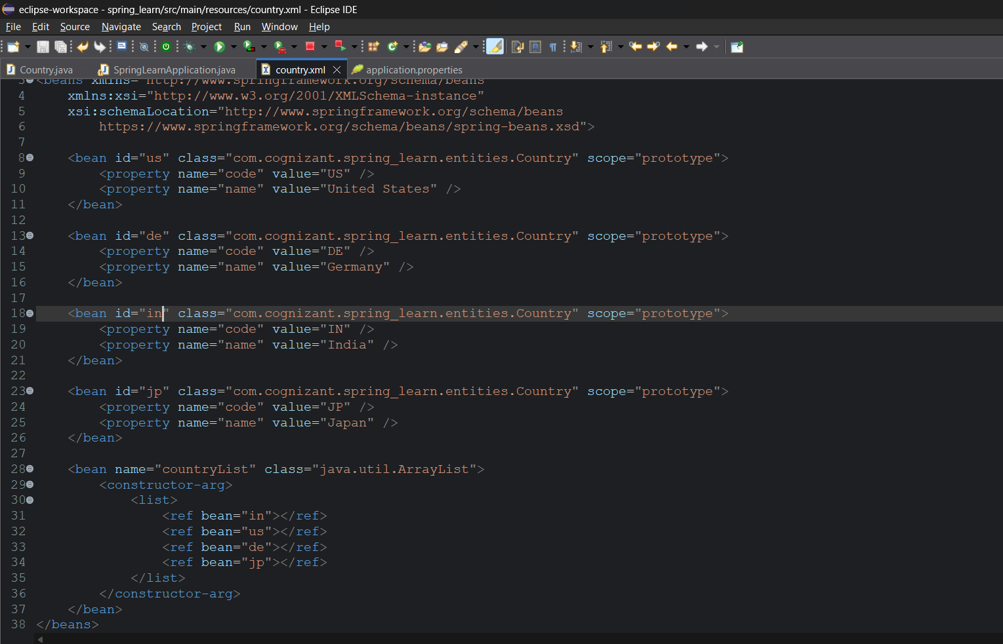
Added displayCountries() method
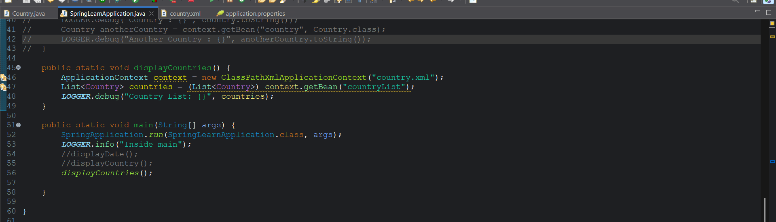
Output:
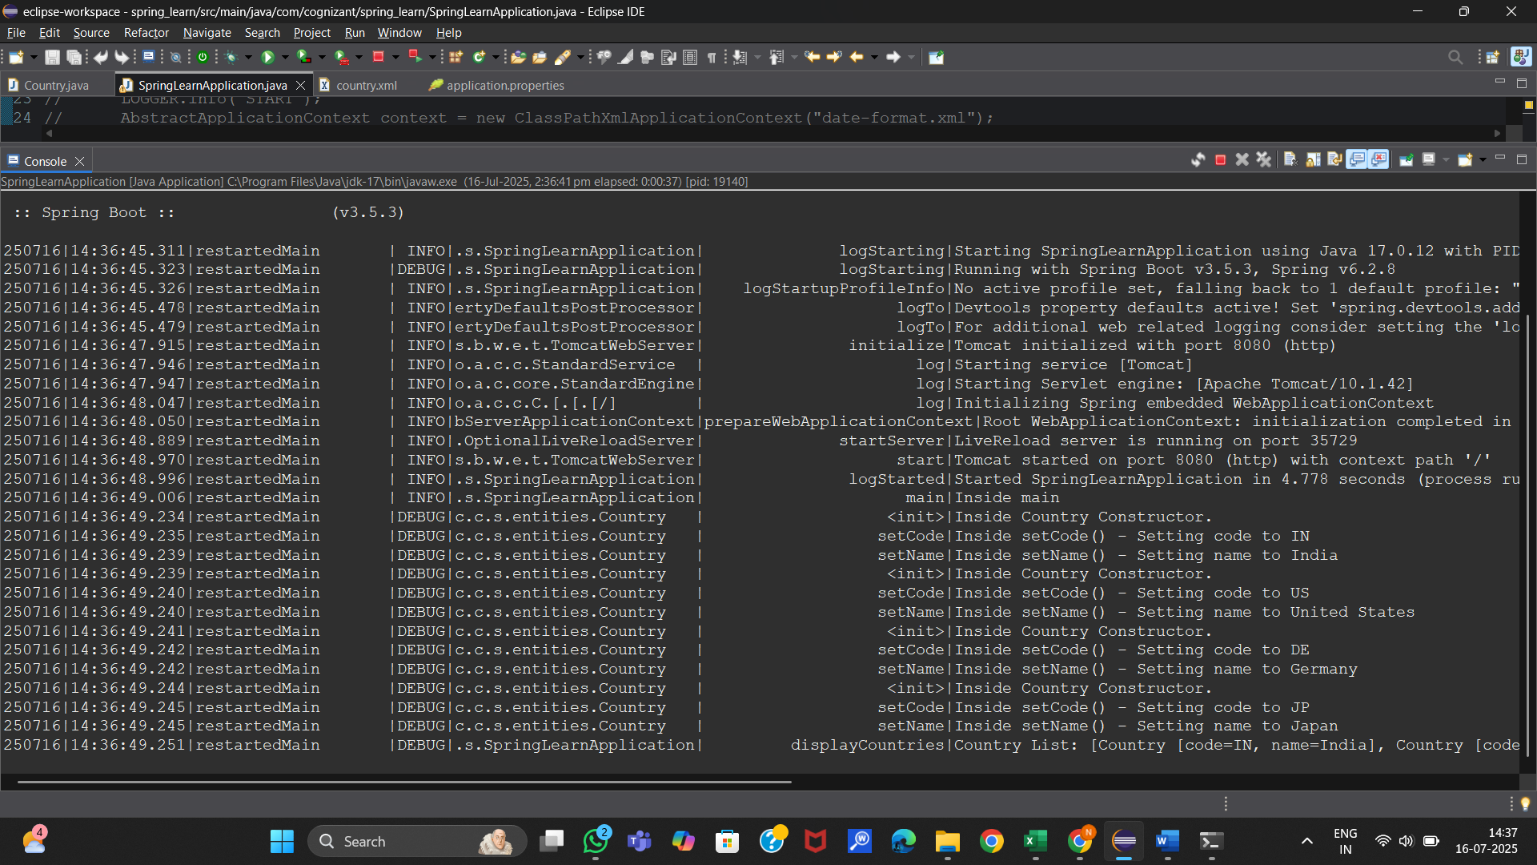
List of the countries is displayed as shown

